Title

Author Name＊a), Membership Category of IEEJ, Author Name＊, Membership Category of IEEJ

Abstract the quick brown fox jump over the lazy dog. The quick brown fox jump over the lazy dog. The quick brown fox jump over the lazy dog. The quick brown fox jump over the lazy dog. The quick brown fox jump over the lazy dog. The quick brown fox jump over the lazy dog. The quick brown fox jump over the lazy dog. The quick brown fox jump over the lazy dog. The quick brown fox jump over the lazy dog. The quick brown fox jump over the lazy dog.

**Keywords** : keyword1, keyword2, keyword3, keyword4, keyword5

a) Correspondence to: Taro Denshi. E-mail: TaroDenshi@iee.or.jp

＊ The quick brown fox jump over the lazy dog. Co., Ltd.  
0-0, Ichibancho, Chiyoda-ku, Tokyo, Japan 000-0000

1. Section

The quick brown fox jump over the lazy dog[1]. The quick brown fox jump over the lazy dog [2,3]. The quick brown fox jump over the lazy dog [1-3]. The quick brown fox jump over the lazy dog. The quick brown fox jump over the lazy dog. The quick brown fox jump over the lazy dog. The quick brown fox jump over the lazy dog. The quick brown fox jump over the lazy dog. The quick brown fox jump over the lazy dog. The quick brown fox jump over the lazy dog. The quick brown fox jump over the lazy dog. The quick brown fox jump over the lazy dog. The quick brown fox jump over the lazy dog. The quick brown fox jump over the lazy dog. The quick brown fox jump over the lazy dog. The quick brown fox jump over the lazy dog. The quick brown fox jump over the lazy dog. The quick brown fox jump over the lazy dog. The quick brown fox jump over the lazy dog. The quick brown fox jump over the lazy dog. The quick brown fox jump over the lazy dog. The quick brown fox jump over the lazy dog. The quick brown fox jump over the lazy dog. The quick brown fox jump over the lazy dog. The quick brown fox jump over the lazy dog. The quick brown fox jump over the lazy dog. The quick brown fox jump over the lazy dog.

 (1)

The quick brown fox jump over the lazy dog. The quick brown fox jump over the lazy dog. The quick brown fox jump over the lazy dog. The quick brown fox jump over the lazy dog. The quick brown fox jump over the lazy dog. The quick brown fox jump over the lazy dog. The quick brown fox jump over the lazy dog. The quick brown fox jump over the lazy dog. The quick brown fox jump over the lazy dog. The quick brown fox jump over the lazy dog. The quick brown fox jump over the lazy dog. The quick brown fox jump over the lazy dog. The quick brown fox jump over the lazy dog. The quick brown fox jump over the lazy dog. The quick brown fox jump over the lazy dog. The quick brown fox jump over the lazy dog. The quick brown fox jump over the lazy dog. The quick brown fox jump over the lazy dog. The quick brown fox jump over the lazy dog. The quick brown fox jump over the lazy dog. The quick brown fox jump over the lazy dog. The quick brown fox jump over the lazy dog. The quick brown fox jump over the lazy dog. The quick brown fox jump over the lazy dog. The quick brown fox jump over the lazy dog. The quick brown fox jump over the lazy dog. The quick brown fox jump over the lazy dog. The quick brown fox jump over the lazy dog. The quick brown fox jump over the lazy dog.



図表説明（中央）□□□□□表の左右は，75mm以内□□□□□.

Fig. 1. Figure caption.

2. Section

2.1 Subsection The quick brown fox jump over the lazy dog. The quick brown fox jump over the lazy dog. The quick brown fox jump over the lazy dog. The quick brown fox jump over the lazy dog. The quick brown fox jump over the lazy dog. The quick brown fox jump over the lazy dog. The quick brown fox jump over the lazy dog. The quick brown fox jump over the lazy dog. The quick brown fox jump over the lazy dog. The quick brown fox jump over the lazy dog. The quick brown fox jump over the lazy dog. The quick brown fox jump over the lazy dog. The quick brown fox jump over the lazy dog.

2.2 Subsection The quick brown fox jump over the lazy dog. The quick brown fox jump over the lazy dog. The quick brown fox jump over the lazy dog. The quick brown fox jump over the lazy dog. The quick brown fox jump over the lazy dog. The quick brown fox jump over the lazy dog. The quick brown fox jump over the lazy dog. The quick brown fox jump over the lazy dog. The quick brown fox jump over the lazy dog. The quick brown fox jump over the lazy dog. The quick brown fox jump over the lazy dog.

The quick brown fox jump over the lazy dog. The quick brown fox jump over the lazy dog. The quick brown fox jump over the lazy dog. The quick brown fox jump over the lazy dog. The quick brown fox jump over the lazy dog. The quick brown fox jump over the lazy dog. The quick brown fox jump over the lazy dog. The quick brown fox jump over the lazy dog. The quick brown fox jump over the lazy dog. The quick brown fox jump over the lazy dog. The quick brown fox jump over the lazy dog. The quick brown fox jump over the lazy dog. The quick brown fox jump over the lazy dog.

Table 1. Table caption.

|  |  |  |  |  |
| --- | --- | --- | --- | --- |
|  |  |  |  |  |
| Table Strings |  |  |  |  |
|  |  |  |  |  |

図表説明（左寄せ）□□図・表は，ページの「上」又は「下」に配置。本文と図・表の間は，１行空き.

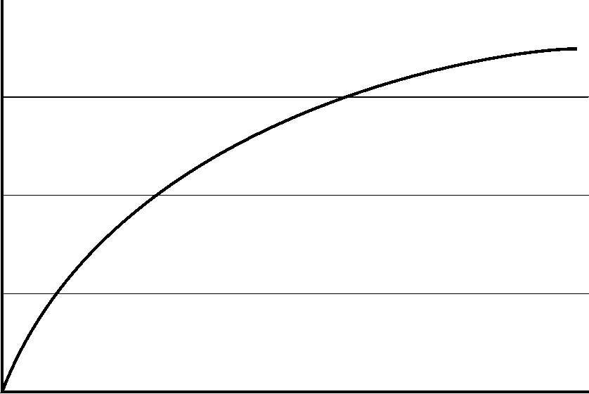

(a) Figure Sub caption



(b) Figure Sub caption

Fig. 2. Figure caption.

The quick brown fox jump over the lazy dog. The quick brown fox jump over the lazy dog. The quick brown fox jump over the lazy dog. The quick brown fox jump over the lazy dog. The quick brown fox jump over the lazy dog. The quick brown fox jump over the lazy dog. The quick brown fox jump over the lazy dog. The quick brown fox jump over the lazy dog. The quick brown fox jump over the lazy dog. The quick brown fox jump over the lazy dog. The quick brown fox jump over the lazy dog. The quick brown fox jump over the lazy dog. The quick brown fox jump over the lazy dog.

The quick brown fox jump over the lazy dog. The quick brown fox jump over the lazy dog. The quick brown fox jump over the lazy dog. The quick brown fox jump over the lazy dog. The quick brown fox jump over the lazy dog. The quick brown fox jump over the lazy dog. The quick brown fox jump over the lazy dog. The quick brown fox jump over the lazy dog. The quick brown fox jump over the lazy dog. The quick brown fox jump over the lazy dog. The quick brown fox jump over the lazy dog. The quick brown fox jump over the lazy dog. The quick brown fox jump over the lazy dog.

The quick brown fox jump over the lazy dog. The quick brown fox jump over the lazy dog. The quick brown fox jump over the lazy dog. The quick brown fox jump over the lazy dog. The quick brown fox jump over the lazy dog. The quick brown fox jump over the lazy dog. The quick brown fox jump over the lazy dog. The quick brown fox jump over the lazy dog. The quick brown fox jump over the lazy dog. The quick brown fox jump over the lazy dog. The quick brown fox jump over the lazy dog. The quick brown fox jump over the lazy dog. The quick brown fox jump over the lazy dog.

The quick brown fox jump over the lazy dog. The quick brown fox jump over the lazy dog. The quick brown fox jump over the lazy dog. The quick brown fox jump over the lazy dog. The quick brown fox jump over the lazy dog. The quick brown fox jump over the lazy dog. The quick brown fox jump over the lazy dog. The quick brown fox jump over the lazy dog. The quick brown fox jump over the lazy dog. The quick brown fox jump over the lazy dog. The quick brown fox jump over the lazy dog. The quick brown fox jump over the lazy dog. The quick brown fox jump over the lazy dog.

The quick brown fox jump over the lazy dog. The quick brown fox jump over the lazy dog. The quick brown fox jump over the lazy dog. The quick brown fox jump over the lazy dog. The quick brown fox jump over the lazy dog. The quick brown fox jump over the lazy dog. The quick brown fox jump over the lazy dog. The quick brown fox jump over the lazy dog. The quick brown fox jump over the lazy dog. The quick brown fox jump over the lazy dog. The quick brown fox jump over the lazy dog. The quick brown fox jump over the lazy dog. The quick brown fox jump over the lazy dog.

The quick brown fox jump over the lazy dog. The quick brown fox jump over the lazy dog. The quick brown fox jump over the lazy dog. The quick brown fox jump over the lazy dog. The quick brown fox jump over the lazy dog. The quick brown fox jump over the lazy dog. The quick brown fox jump over the lazy dog. The quick brown fox jump over the lazy dog. The quick brown fox jump over the lazy dog. The quick brown fox jump over the lazy dog. The quick brown fox jump over the lazy dog. The quick brown fox jump over the lazy dog. The quick brown fox jump over the lazy dog.

3. Section

The quick brown fox jump over the lazy dog. The quick brown fox jump over the lazy dog. The quick brown fox jump over the lazy dog. The quick brown fox jump over the lazy dog. The quick brown fox jump over the lazy dog. The quick brown fox jump over the lazy dog.

References

(1) Author : “title”, journal title, Vol.00, No.000, pp.000-000 (pub. year)

(2) Author and Author : “title”, journal title, Vol.00, No.000, pp.000-000 (pub. year)

(3) Author, Author, and Author : “title”, journal title, Vol.00, No.000, pp.000-000 (pub. year)