Title for PES

Author Name^{＊a)}, Membership Category of IEEJ, Author Name＊, Membership Category of IEEJ

Keywords : keyword1, keyword2

1. Section
a) Correspondence to: Author Name. E-mail: AuthorName@iee.or.jp
＊ The quick brown fox jump over the lazy dog. Co., Ltd.
0-0, Ichibancho, Chiyoda-ku, Tokyo, Japan 000-0000
The quick brown fox jump over the lazy dog. The quick brown fox jump over the lazy dog. The quick brown fox jump over the lazy dog. The quick brown fox jump over the lazy dog. The quick brown fox jump over the lazy dog. The quick brown fox jump over the lazy dog. The quick brown fox jump over the lazy dog. The quick brown fox jump over the lazy dog. The quick brown fox jump over the lazy dog. The quick brown fox jump over the lazy dog. The quick brown fox jump over the lazy dog. The quick brown fox jump over the lazy dog. The quick brown fox jump over the lazy dog. The quick brown fox jump over the lazy dog. The quick brown fox jump over the lazy dog. The quick brown fox jump over the lazy dog. The quick brown fox jump over the lazy dog. The quick brown fox jump over the lazy dog. The quick brown fox jump over the lazy dog. The quick brown fox jump over the lazy dog. The quick brown fox jump over the lazy dog. The quick brown fox jump over the lazy dog. The quick brown fox jump over the lazy dog. The quick brown fox jump over the lazy dog. The quick brown fox jump over the lazy dog. The quick brown fox jump over the lazy dog. The quick brown fox jump over the lazy dog.
(1)
The quick brown fox jump over the lazy dog. The quick brown fox jump over the lazy dog. The quick brown fox jump over the lazy dog. The quick brown fox jump over the lazy dog. The quick brown fox jump over the lazy dog. The quick brown fox jump over the lazy dog. The quick brown fox jump over the lazy dog. The quick brown fox jump over the lazy dog. The quick brown fox jump over the lazy dog. The quick brown fox jump over the lazy dog. The quick brown fox jump over the lazy dog. The quick brown fox jump over the lazy dog. The quick brown fox jump over the lazy dog. The quick brown fox jump over the lazy dog. The quick brown fox jump over the lazy dog. The quick brown fox jump over the lazy dog. The quick brown fox jump over the lazy dog. The quick brown fox jump over the lazy dog. The quick brown fox jump over the lazy dog. The quick brown fox jump over the lazy dog. The quick brown fox jump over the lazy dog. The quick brown fox jump over the lazy dog. The quick brown fox jump over the lazy dog. The quick brown fox jump over the lazy dog. The quick brown fox jump over the lazy dog. The quick brown fox jump over the lazy dog. The quick brown fox jump over the lazy dog. The quick brown fox jump over the lazy dog. The quick brown fox jump over the lazy dog.

Explanation of the figure (Centering). Sentences with within 75mm.
Fig. 1. Figure caption.

2. Section
2.1 Subsection The quick brown fox jump over the lazy dog. The quick brown fox jump over the lazy dog. The quick brown fox jump over the lazy dog. The quick brown fox jump over the lazy dog. The quick brown fox jump over the lazy dog. The quick brown fox jump over the lazy dog. The quick brown fox jump over the lazy dog. The quick brown fox jump over the lazy dog. The quick brown fox jump over the lazy dog. The quick brown fox jump over the lazy dog. The quick brown fox jump over the lazy dog. The quick brown fox jump over the lazy dog. The quick brown fox jump over the lazy dog.
2.2 Subsection The quick brown fox jump over the lazy dog. The quick brown fox jump over the lazy dog. The quick brown fox jump over the lazy dog. The quick brown fox jump over the lazy dog. The quick brown fox jump over the lazy dog. The quick brown fox jump over the lazy dog. The quick brown fox jump over the lazy dog. The quick brown fox jump over the lazy dog. The quick brown fox jump over the lazy dog. The quick brown fox jump over the lazy dog. The quick brown fox jump over the lazy dog.
The quick brown fox jump over the lazy dog. The quick brown fox jump over the lazy dog. The quick brown fox jump over the lazy dog. The quick brown fox jump over the lazy dog. The quick brown fox jump over the lazy dog. The quick brown fox jump over the lazy dog. The quick brown fox jump over the lazy dog. The quick brown fox jump over the lazy dog. The quick brown fox jump over the lazy dog. The quick brown fox jump over the lazy dog. The quick brown fox jump over the lazy dog. The quick brown fox jump over the lazy dog. The quick brown fox jump over the lazy dog. (10)
The quick brown fox jump over the lazy dog. The quick brown fox jump over the lazy dog. The quick brown fox jump over the lazy dog. The quick brown fox jump over the lazy dog. The quick brown fox jump over the lazy dog. The quick brown fox jump over the lazy dog. The quick brown fox jump over the lazy dog. The quick brown fox jump over the lazy dog. The quick brown fox jump over the lazy dog. The quick brown fox jump over the lazy dog. The quick brown fox jump over the lazy dog. The quick brown fox jump over the lazy dog. The quick brown fox jump over the lazy dog. (20)
The quick brown fox jump over the lazy dog. The quick brown fox jump over the lazy dog. The quick brown fox jump over the lazy dog. The quick brown fox jump over the lazy dog. The quick brown fox jump over the lazy dog. The quick brown fox jump over the lazy dog. The quick brown fox jump over the lazy dog. The quick brown fox jump over the lazy dog. The quick brown fox jump over the lazy dog. The quick brown fox jump over the lazy dog. The quick brown fox jump over the lazy dog. The quick brown fox jump over the lazy dog. The quick brown fox jump over the lazy dog. (30)
The quick brown fox jump over the lazy dog. The quick brown fox jump over the lazy dog. The quick brown fox jump over the lazy dog. The quick brown fox jump over the lazy dog. The quick brown fox jump over the lazy dog. The quick brown fox jump over the lazy dog. The quick brown fox jump over the lazy dog. The quick brown fox jump over the lazy dog. The quick brown fox jump over the lazy dog. The quick brown fox jump over the lazy dog. The quick brown fox jump over the lazy dog. The quick brown fox jump over the lazy dog. The quick brown fox jump over the lazy dog. (40)
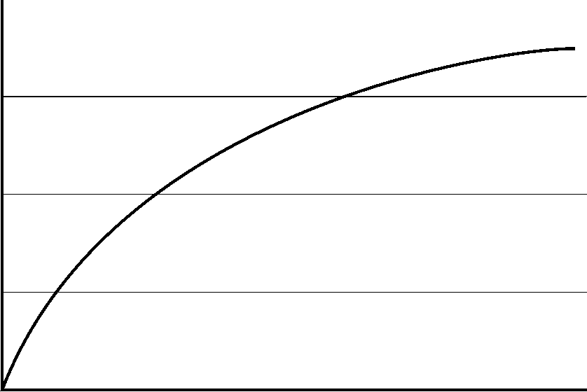
(a) Figure Sub caption
(b) Figure Sub caption
Fig. 2. Figure caption.

The quick brown fox jump over the lazy dog. The quick brown fox jump over the lazy dog. The quick brown fox jump over the lazy dog. The quick brown fox jump over the lazy dog. The quick brown fox jump over the lazy dog. The quick brown fox jump over the lazy dog. The quick brown fox jump over the lazy dog. The quick brown fox jump over the lazy dog. The quick brown fox jump over the lazy dog. The quick brown fox jump over the lazy dog. The quick brown fox jump over the lazy dog. The quick brown fox jump over the lazy dog. The quick brown fox jump over the lazy dog. (50)
The quick brown fox jump over the lazy dog. The quick brown fox jump over the lazy dog. The quick brown fox jump over the lazy dog. The quick brown fox jump over the lazy dog. The quick brown fox jump over the lazy dog. The quick brown fox jump over the lazy dog. The quick brown fox jump over the lazy dog. The quick brown fox jump over the lazy dog. The quick brown fox jump over the lazy dog. The quick brown fox jump over the lazy dog. The quick brown fox jump over the lazy dog. The quick brown fox jump over the lazy dog. The quick brown fox jump over the lazy dog. (60)
The quick brown fox jump over the lazy dog. The quick brown fox jump over the lazy dog. The quick brown fox jump over the lazy dog. The quick brown fox jump over the lazy dog. The quick brown fox jump over the lazy dog. The quick brown fox jump over the lazy dog. The quick brown fox jump over the lazy dog. The quick brown fox jump over the lazy dog. The quick brown fox jump over the lazy dog. The quick brown fox jump over the lazy dog. The quick brown fox jump over the lazy dog. The quick brown fox jump over the lazy dog. The quick brown fox jump over the lazy dog. (70)
The quick brown fox jump over the lazy dog. The quick brown fox jump over the lazy dog. The quick brown fox jump over the lazy dog. The quick brown fox jump over the lazy dog. The quick brown fox jump over the lazy dog. The quick brown fox jump over the lazy dog. The quick brown fox jump over the lazy dog. The quick brown fox jump over the lazy dog. The quick brown fox jump over the lazy dog. The quick brown fox jump over the lazy dog. The quick brown fox jump over the lazy dog. The quick brown fox jump over the lazy dog. The quick brown fox jump over the lazy dog. (80)
The quick brown fox jump over the lazy dog. The quick brown fox jump over the lazy dog. The quick brown fox jump over the lazy dog. The quick brown fox jump over the lazy dog. The quick brown fox jump over the lazy dog. The quick brown fox jump over the lazy dog. The quick brown fox jump over the lazy dog. The quick brown fox jump over the lazy dog. The quick brown fox jump over the lazy dog.
Table 1. Table caption.
Table Strings
Explanation of the table (Left-aligned). Place the figures and the tables on “upside” or “downside” of each page. Insert a blank line between the body and the figure/table

References
(1) Author: “title”, journal title, Vol.00, No.000, pp.000-000 (pub. year)
(2) Author and Author: “title”, journal title, Vol.00, No.000, pp.000-000 (pub. year)
(3) Author, Author, and Author: “title”, journal title, Vol.00, No.000, pp.000-000 (pub. year)

